

Contents

1 Executive Summary 3

2 Business Challenges 4

3 Product Overview 7

3.1 Basic Functionality 7

3.2 Product Features 8

4 Overall Benefits 14

4.1 Making the Case 14

4.2 Benefits for Your Operations Departments 15

4.3 Benefits for IT 16

5 Solution Differentiators 17

6 Related Solutions and Services 18

6.1 Consulting and Implementation Services 18

6.2 Related Products and Solutions 19

7 Ericsson as Your Partner 20

|  |
| --- |
| © Ericsson AB 2014  All rights reserved. The information in this document is the property of Ericsson. Except as specifically authorized in writing by Ericsson, the receiver of this document shall keep the information contained herein confidential and shall protect the same in whole or in part from disclosure and dissemination to third parties. Disclosure and disseminations to the receiver's employees shall only be made on a strict need to know basis. |

# Executive Summary

Today’s fixed and mobile operators are facing unprecedented customer demands, product complexity, and margin pressures. There isn’t a single one that doesn’t want to increase revenue and reduce costs while attracting and retaining customers. As bandwidth and services have become commoditized, operators know they must differentiate themselves with better service, better support, and faster delivery of complex offers. They are under intense competitive and financial pressure to deploy new services more quickly and make their operations more efficient.

With multiple piece parts to deal with, service order processing is a complex task. You may be using multiple order entry mechanisms, process flows, and order engines – all of which add to the complexity, and make end-to-end workflow integration quite a challenge. With the explosive demand for new services, time-to-market is of the essence. Legacy systems were built to support the traditional telecom model of one product delivered the same way to millions of customers. But that doesn’t apply anymore.

As a result, you may be facing significant changes configuring new service stacks in your current order management systems, needing a great deal of customization and associated maintenance expense. Most current solutions cannot consistently coordinate a wide array of activities across services, supporting systems, and work centers. No matter how much automation or how many process improvements are made to the old way of doing business, they will not provide the agility and fast time to market required by today’s complex, bundled and often customized services. This lack of coordination results in operational errors and delays, and fails to provide meaningful feedback to drive process and organizational improvements.

To deliver these new converged services, many operators have undertaken massive business transformations to consolidate into fewer, more flexible systems. This can be challenging since many legacy systems have their own processes as well as data silos, making it difficult to rationalize the systems while maintaining data integrity. At the end of the day, complex order management and provisioning processes have remained dominated by manual work steps. This needs to change.

Ericsson Order Care addresses these challenges with a fully configurable system that begins with coordinated order negotiation support then handles automated workflows and manual work activities across services, systems and groups. It automates the orchestration of service orders through validation, decomposition, order processing, routing and status tracking. With its metadata-driven approach, it expedites new product launches by enabling the quick creation of order management workflows and adjustments to existing business processes.

In addition, Ericsson Order Care manages manual work activities that arise during the normal course of business, and ensures that appropriately qualified people are assigned a prioritized and balanced work load.

The system coordinates and tracks the status of these activities across disparate services, systems and groups. A fully customizable monitoring and reporting framework provides end-to-end visibility to proactively manage and improve processes, track status, and analyze historical information. The result is consistent fulfillment of services across domains and technologies with a repeatable methodology for product introduction.

With higher operational efficiency using Ericsson Order Care, you can:

* Reduce system and operational cost by coordinating automated service order processing and manual work activities.
* Increase deployment speed by reusing proven workflows and easily customizing business logic and system interfaces.
* Drive continuous process improvement using reports and analytics.

Ericsson provides a comprehensive solution to automate order processing and manage any manual needs that arise, seamlessly providing the coordination you need to grow your business. Ericsson customers have reported these benefits that you can also achieve:

* 96% less time to process service orders
* 90% less time handing manual work items
* 80% fewer missed due dates
* 95% or greater service order flow-through
* 33% fewer staff hours to manage manual work

This document describes the need for a proven solution. One that addresses order management, service fulfillment and task management on a single platform for creating and orchestrating automated workflows and manual work activities across services, systems, processes and groups. It provides an overview of Ericsson Order Care and highlights real business value that can be gained through implementation of this product.

# Business Challenges

Your operations are most likely incapable of supporting the business change or development programs you are looking to execute if you dealing with:

* Inconsistent customer experience and fragmented, disconnected processes.
* Inaccurate service fulfillment with a high fallout rate and other delays.
* Slow, manual service order handling and unattainable levels of automation.
* Slow resolution of service order errors or other manual activities.
* Limited operational visibility of service order status.
* Lack of effective staff management tools leading to low staff productivity.
* System integration challenges resulting from merger and acquisition activities.

You may overwhelmed by increasingly complex or high-volume services that should be orderable anywhere over any type of delivery channel. One of your biggest struggles is the need for end-to-end visibility into all your service orders across all your product lines. Success demands proven best practices and a standard, structured approach that is synchronized with product catalogs and inventory systems for service qualification, order status, and orchestration.

While you may be keenly focused on gaining operational efficiencies via process automation, you may not have effective methods to handle those activities that you choose not to automate and those that must be performed by staff experts. And even those activities that have been automated may eventually break at some point thus requiring efficiently coordinated staff intervention.

Most current solutions cannot consistently coordinate and complete these types of activities across services, supporting systems and work centers. This lack of coordination results in operational errors and delays, and fails to provide the kind of feedback you need to drive process and organizational improvements.

Your current operational environment presents a myriad of challenges in negotiating and fulfilling the order, as shown in Figure 1.

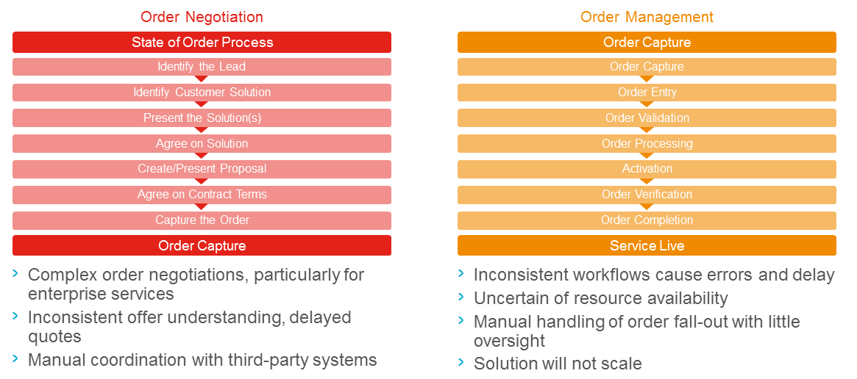

Figure : Common Operational Challenges

You may be missing a common order processing platform to handle your growing number of services in an automated fashion. Even if you have one, it probably cannot consistently coordinate related manual work activities in conjunction with the mechanized portion of the order. You may be having difficulties in tracking the status of manual work activities due to the lack of end-to-end visibility across your multiple systems and departments.

Similarly, when a service order fails, you may be having difficulties tracking its status because resolution is needed in multiple systems and/or departments. Rollback on errors is handled differently by each technician and is not centrally tracked. Most current service order management systems cannot provide an end-to-end 360-degree view of the status of an order and its suborders. In general, the handling of errors and process exceptions is inconsistent and it is difficult to identify the primary owner.

Reporting is often an exercise in retracing what happened − not what is needed right now − and it is usually based upon inconsistent and incomplete data.

On top of these daily operational issues, customizing your current service provisioning platform may be labor-intensive – usually involving long lead times. Specialized knowledge and development tools are typically required to run and maintain these platforms as well as the associated middleware. It takes too long to develop provisioning capabilities to support a new service and to modify these platforms when there is a slight service change.

In addition, your IT organization may be relying on disparate systems or approaches to effectively handle the many types of workflows and manual work activities. Or you may be in the middle of a merger or acquisition consolidation that requires the integration of various separate systems. Without a common platform, orchestrating legacy and next generation operational systems often relies on point-to-point integrations that are time consuming to develop and impossible to maintain.

Operators have spent billions on infrastructure and systems to improve operations and it has helped. But the pace is picking up and competitors are bearing down. Something needs to be done to streamline order management– soon.

Since it is not economical to throw out all those existing systems and since continued software development will quickly become cost prohibitive, the answer lies in implementing a holistic customer layer that leverages existing systems and data to deliver optimized processes for customer lifecycle management, product lifecycle management, and order lifecycle management − across any service, any network, any market, or any channel.

This new order management paradigm must go beyond order capture to include order orchestration across legacy system silos. Order orchestration must facilitate fulfillment and activation, fallout management, customer self-care, and oversight of all those activities so that problems can be caught early and fixed quickly. To manage the order requires customer data, product data, service data, inventory data, billing data, partner data, and content data – all in a coordinated fashion.

# Product Overview

## Basic Functionality

Ericsson Order Care is a proven order management platform for creating and orchestrating automated workflows and streamlining manual work activities across services, systems, processes and groups. It automates the orchestration of service orders through validation, decomposition, order processing, routing and status tracking.

With its order negotiation capability, Ericsson Order Care lets you manage the lifecycle of the customer and their orders. Using a user-friendly wizard of your own design, you guide customers through the order capture process, including quoting, selling, ordering, validating and approving credit. These screens can be used by any channel – your customer service representatives, your partners, or via customer self-service.

With its powerful workflow engine and ability to coordinate manual work activities, Ericsson Order Care can be used in project management activities that typically have a longer-term duration than service orders, for example to support product management, provisioning, assurance, engineering and network build projects.

Ericsson Order Care handles multi-site, multi-service order structures with configurable workflows along with flexible policies to fulfill partial orders, escalate stalled orders, and rollback failed or cancelled orders of any type. It also provides updates to external systems to reflect real-time order status.

Ericsson Order Care handles a range of manual work activities including projects, planned and unplanned work items, and exceptions. It coordinates and tracks these activities across disparate services, systems, and groups. The system provides enhanced distribution and management of work items through configurable business rules for work assignments, prioritization and load balancing methods and data analytics. Work items can be prioritized by type of service, customer, geographic data, or other user-defined criteria, including configurable business flows.

The system’s reporting features provide end-to-end visibility of your processes so you can proactively manage and improve them, while its dashboards facilitate business decision making.

In short, Ericsson provides a complete order management solution on a single pre-integrated platform as shown in the figure below.

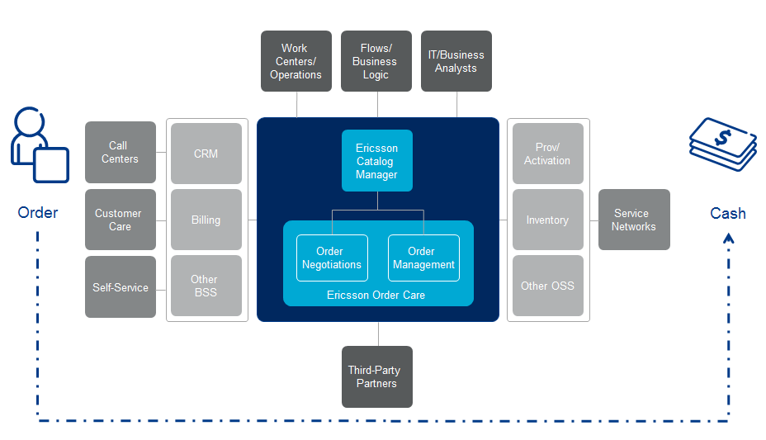

Figure : Ericsson Order Care Functional Architecture

With Ericsson Order Care you can:

* Manage service orders from start to finish with an end-to-end view of order status that can be leveraged across existing disparate systems and can integrate with other order management systems as necessary.
* Manage a wide range of manual work activities across all of your services, systems, processes and groups.
* Generate reports that provide customized views of process status and historical information, productivity, work item statistics and trend analysis.

## Product Features

**Workflow Engine**

At its core, Ericsson Order Care provides a powerful workflow engine that is used to automate service order orchestration and to handle exceptions, errors, and manual work items. You can quickly customize it to support your specific business rules and required system interactions, define a range of resolution flows, and assign manual work steps, process exceptions, or notifications. It can also provide custom views for technicians, project managers, and supervisors that include status tracking and metrics such as technician workload and work completion history.

**Order Negotiations**

The Order Negotiations feature in Ericsson Order Care provides you with the tools to centralize order capture, validate every order prior to provisioning, and deploy new products more effectively, all with a greater level of automation.

It uses a wizard-driven GUI to guide the user through the order capture process – from quotation, sales and order, to credit approval. The sophisticated screens capture data for any product or service, including complex bundles and offers. They also handle all order lifecycle transactions including new, add, move, supplement, cancel, suspend, and disconnect orders. The data capture capability can extend beyond your own customer service representatives (CSR), ranging from customer self-serve to channel partners and suppliers.

Order Negotiations uses a catalog-driven process to ensure your customers’ first impressions are flawless, and all aspects of an order are valid and accurate. This provides a consistent, high-quality user experience with rich functionality and zero errors with the following results:

* Unified sales management across all channels
* Consistent product inquiry and ordering
* Enabling a selling approach that is tailored to the individual subscriber
* Reduced cost-per-order through efficient order capture and validation
* Faster time-to-market and time-to-revenue
* Improved inquiry-to-order conversion ratio

**Service Order Management**

Ericsson Order Care is a complete service order management solution that is available on the same platform as Ericsson Catalog Manager. When combined, these two products provide a catalog-driven approach to service fulfillment using components that can be used, reused, and re-configured to provide repeatable processes that lead to reduced fallout and faster time-to-service. The table below summarizes key capabilities in support of service order processing.

Table Service Order Management Functions Supported

|  |  |
| --- | --- |
| Process | Functions |
| Order Negotiation | * Present options to customer from catalog * Check availability * Select service and features * Validate and capture commercial order |
| Order Decomposition | * Decompose into subtending technical orders with dependencies * Check resources are available in inventory |
| Provisioning and Dispatch | * Send technical orders to downstream systems * Send manual work orders to workforce management * Send completion notifications to billing and assurance systems * Use analytics to optimize operations |
| Tracking and Management | * Provide order status updates to customer-facing systems * Provide supervisors with tools to monitor status and productivity * Facilitate continuous improvement |

With Ericsson Order Care, you can use and reuse telecom-aware workflows for faster time-to-market − workflows that are certified to meet TM Forum standards, so you can accelerate your project deployments. All of these features are enabled through an intuitive GUI that lets your business analysts configure, test, and rapidly deploy or update order management functionality.

**Exception and Manual Task Management**

Ericsson Order Care manages a range of manual work activities that may arise in your operational environment – either planned or unplanned. It receives these work activities from one or more sending systems, then processes and routes them to the appropriate system, work center, group, or technician. It also provides work center supervisors with a powerful range of out-of-the-box tools for workload management to assign, balance and prioritize work. The system generates lists of work activities for each user and work center, and automatically updates them upon work completion or suspension.

The work item management capabilities are designed to fill any gaps in your current operational environment with a mix of work handling approaches:

* Manual – enables reliable, consistent assignment, management, and reporting of work items across all of your work centers, systems, and processes
* Assisted – Automates a high percentage of repetitive manual tasks, including background information gathering, data consistency checks, and work item resubmissions
* Automated – Uses business rules and/or workflows to automatically handle, resolve, and assign work items

Ericsson Order Care supports customized user profile definitions for skill sets and authorizations used to assign work to your technicians. As you create user accounts, you map each technician to an appropriate group. When your users request a new work item, only items that match their skill set are considered for assignment. When a workflow and/or business rule executes, Ericsson Order Care compares the permissions corresponding to the task to the permissions that have been granted to the user. Your users are only allowed to work on tasks if they have the appropriate authorization. If necessary, you can change the permissions as the workflow progresses, allowing updates to an order or work item to occur only at the appropriate time. In addition, when your users navigate through the GUI, only those screens they are authorized to use will appear.

**Approach to Configuration**

Employing a metadata-driven approach, Ericsson Order Care gives you predefined templates and interfaces to shorten the time to market your new product launches as well as the inevitable adjustments to existing processes and services. It enables you to rapidly build and change business logic, workflow, and system interfaces with minimal scripting. At the same time, the predefined templates and interfaces can be used as quick, inexpensive starting points to introduce new services.

**Integration into a Provisioning Ecosystem**

Because Ericsson Order Care is highly configurable, you can offer customers the most flexible and agile response to their changing telecom needs. Innovative order and service decomposition and orchestration capabilities enable you to match components and communicate with multiple back-end systems, as well as manual processes.

You can cleanly decouple the centralized order fulfillment solution from surrounding systems such as customer relationship management and billing, to ensure clean, accurate orders. You can count on fewer downstream billing errors and adjustments, radically reduced fallout, increased customer satisfaction and quicker time to revenue.

This proven solution will help you acquire new customers, build loyalty, and set the stage for successful up-sell and cross-sell initiatives with:

* Faster response to service inquiries and requests
* Quicker, more accurate fulfillment processes plus reduced revenue leakage
* Reliable decomposition and orchestration of orders including partner products
* Significantly lower total-cost-of-ownership on all your fulfillment efforts
* Increased customer satisfaction and loyalty

**Comprehensive Order Management**

Ericsson Order Care is a software solution that gives you the level of coordination you need to orchestrate and automate all of your order workflows and manual work activities. To help you achieve high levels of order automation and improve overall operational efficiency, the solution allows   
you to:

* Fully manage the customer lifecycle with customer relationship functions including site and account management.
* Unify order entry, service negotiation, customer management, and order issuance functionality.
* Handle orders that have been submitted through a call center or other avenues such as SMS or a self-care portal.
* Leverage a central or federated catalog, including pre-integrated Ericsson Catalog Manager, to coordinate the commercial order with service inventory, provisioning and activation.
* Decompose orders, route them to systems and workgroups, and track their status.
* Coordinate with and provide appropriate information to billing and assurance.
* Support project management activities in product management, provisioning, assurance, engineering, and network build
* Count on a highly reliable, available, and scalable workflow engine that can manage transactions between disparate systems and handle any exceptions generated by them.
* Use graphical and table value reports to facilitate decision management support and reporting of order-based key performance indicators.
* Readily integrate with surrounding systems using application programming interfaces (APIs) to enable execution of transactions to external systems, including automatic resolution systems. Workflows in Ericsson Order Care can interface with other systems via standard protocols and web services.

All of these functions are standard features in Ericsson Order Care.

# Overall Benefits

With Ericsson Order Care, you can significantly improve your operational environment with faster, more accurate order management. Using a single system to manage and automate service order processing – one that typically relies on disparate systems and manual work activities – you can increase the ease and speed of launching and fulfilling new products. With a metadata-driven platform to create, customize, and maintain consistent business rules, logic and workflows, you can increase your level of flow-through processing while ensuring that appropriately qualified people are assigned a prioritized and balanced work load. Finally, with a customizable analytics and reporting framework, you can proactively manage and improve your processes, track status trends and analyze historical information, all driving continuous process improvement.

## Making the Case

The business case is typically based on some combination several key factors, described as follows:

Table Business Case Factors

|  |
| --- |
| Business Case Factors and Rationale |
| **Reduced time and cost to deploy new services** due to workflow and business logic customization, enhanced adaptability to new services, systems, and organizational changes, and faster manual task and exception handling.  **Reduced time and cost to process service orders** due to better coordination, enforcing consistent methods and procedures, automation, reduced swivel chair, cleaner orders with less manual processes and rework.  **Greater throughput and flow-through of service orders** due to automated provisioning, less service order fallout, more flexible rollback, and faster order rework, continuous process improvements.  **Avoidance of increasing headcount** due to system consolidation, process automation, simplification of staff tasks, shorter training intervals, and process optimization based on metrics reporting and analytics.  **Reduced penalties** and loss of goodwill from fewer missed due dates and associated service level agreement (SLA) breach penalties.  **Retirement of legacy systems** and associated hardware and maintenance costs due to system consolidation.  **Expedited integration** and more uniform communication to diverse operational systems. Also as a result of merger and acquisition activities, the ability to rapidly develop new interfaces to existing systems. |

The following Ericsson Order Care value points can help you in creating your business case.

Table Ericsson Order Care Value Matrix

|  |  |
| --- | --- |
| Benefit and Typical Results | How Ericsson Order Care Helps |
| More efficient order management   * 96% reduction in order processing time * 90% reduction in manual work item handling time * 95% service order flow-through | * Increase service order flow-through via mechanized process coordination involving both automated workflows and manual work activities. * Proven best practice experience in data and process modeling.   + Reduce manual work item handling time by prioritizing and balancing workloads across systems and groups.   + Process improvement with end-to-end operational visibility and real-time access to data. |
| Faster error handling   * 33% less staff required to manage manual work | * Less staff required to manage manual work by optimizing staff utilization with business rules that prioritize and route work to the most appropriate person.   + Expedite the resolution of errors by gathering and providing timely, relevant information. |
| Superior customer experience with first-time-right order fulfillment   * 95% service order flow-through * 80% reduction in missed due dates | * Enforce consistent and repeatable business processes – including moves, adds, changes, deletes, cancels, and suspend processes. * Provide tools for continuous process improvement. * Reduce missed dates by coordinating among automated service order workflows and manual work activities.   + Increase efficiency by enabling end-to-end visibility of operational performance. |

## Benefits for Your Operations Departments

For Operations, Ericsson Order Care enables you to:

**Sell more effectively**

* Have ready-access to the information you need to sell new services to your customers, enabling a cleaner order negotiation process
* Reduce your service order entry staffing needs on the order of 33% due to system consolidation and process automation
* Enhance your staff’s ability to adapt to new services, systems, and organizational change while lowering your staff training costs
* Reduce operational time and costs by having a single system that automates processes and coordinates any manual activities/exceptions

**Manage service orders faster**

* Reduce your service order processing time on the order of 96% while achieving service order flow-through rates on the order of 95% due to cleaner order processing with less manual processes and rework.
* Reduce the time it takes to handle manual work.
* Resolve service order errors faster by automatically collecting relevant information from multiple systems in real time so that staff can quickly focus on resolving the issue.

**Reduce operational cost**

* Increase productivity by enforcing consistent methods and using built-in tools to understand and incrementally improve operational processes.
* Use your staff more efficiently by applying metrics reporting and minimize the need for additional headcount.

**Coordinate processes**

* Coordinate the manual steps involved in bridging Planning & Engineering, Fulfillment and Assurance to achieve a more cohesive operational environment.
* Support project management and manage the resolution of any order errors including rollbacks, and keeps an end-to-end view of status.

## Benefits for IT

For IT, Ericsson Order Care enables you to:

**Reduce the number of systems to manage**

* Reduce operational costs via system, data and process consolidation, and integrated reporting tools.

**Integrate into your ecosystem**

* Rapidly and effectively integrate your process flows across disparate systems and groups using an extensible data model.
* Easily integrate to any system, either legacy or next-generation, including   
  catalog customer relationship management, billing, number management, service assurance, inventory, and/or activation.
* Leverage Ericsson Catalog Manager for a pre-integrated solution that drives order management through a federated catalog for ease of deployment and accuracy in fulfillment.

**Configure to your needs**

* Employ a modularized, component-based metadata-driven approach with graphical tools to enable you to rapidly maintain and change business logic and workflows.

**Manage the needs of your business**

* Efficiently meet requests for data and operational information across the enterprise.
* Provide operations the tools needed to run the business without constant coordination of IT resources.
* Run a proven system scalable to thousands of users and millions of transactions.

# Solution Differentiators

Ericsson Order Care enables you to manage process automation along with the coordination of manual work activities, while providing end-to-end visibility of status. It coordinates all activities across services, systems and groups with a mix of approaches, including flow-through automation, coordination of manual tasks and project management support.

Its open design facilitates system integration to enable you to manage services in complex operational environments. It reduces the cost and time through systematic distribution of accurate, timely information to the right people and systems – such as providing order status updates to customer relationship management and other systems for higher accuracy of operational and billing data. It accomplishes this without recoding or data duplication.

Ericsson’s proven best practice experience in data and process modeling gets reflected in workflow tools that can handle the most complex processes and a business process library for faster workflow creation and modification. With Ericsson Order Care, you can use and reuse these telecom-aware workflows for faster time-to-market − workflows that are certified to meet TM Forum standards, so you can accelerate your project deployments.

Benefit from the broadest and deepest telecom expertise in the industry to maximize back-office data transparency, process automation, and staff utilization.

# Related Solutions and Services

## Consulting and Implementation Services

The bulk of the work involved in an implementation is not related to the installation itself, but to the retrieval, analysis, translation, and validation of your current configuration data. Ericsson has developed efficient tools and methodologies for tackling this complex process, significantly reducing the time and effort that might otherwise be required. Some of the services available to you include:

* Initial consulting to assess key processes or network strategy
* Project management
* Solution architecture design including hardware configuration
* Implementation/installation services including system configuration or customization
* Integration to other systems or data migration
* Change management and training needs analysis
* Developer/administrator and end-user training
* Support training
* Support services

You can benefit from extensive support, from implementation to continued operations consulting, helping you maximize your operational, network and IT resources as you define your overall business objectives, operational procedures, and workforce responsibilities.

In addition, our Ericsson consultants and architects provide services to assess and ensure the seamless flow of your service orders from the point of initiating the order through your entire provisioning process including dispatch and activation. These consulting services also focus on billing implications, service assurance processes, and the work centers and systems that support these processes. Our recommendations and implementation plans ensure flow-through from service order negotiation to order completion.

## Related Products and Solutions

Ericsson Order Care is part of a suite of products that provides an end-to-end catalog-driven suite of order fulfillment automation software. The Ericsson products that are part of the Ericsson service agility software set includes Ericsson Order Care, Ericsson Catalog Manager, Granite Inventory, Ericsson Discovery and Reconciliation, Ericsson Customer Number Manager, Ericsson Multi Activation, Ericsson Automatic Device Configuration, and Ericsson Remote Device Manager.

In addition, Ericsson Order Care is pre-integrated with Ericsson Catalog Manager to provide dynamic catalog-driven fulfillment. It can also integrate with other fulfillment solutions and catalogs to initiate provisioning, track service orders, and activate services.

With this suite of products you can increase planning efficiency, automate provisioning/activation, reduce service order fallout, and maximize asset utilization and inventory data accuracy. It aligns your service design and fulfillment resources into an automated flow while using proven approaches for managing manual work activities. It ties all your applications in the process to data that is clean and synchronized, while protecting the process with “rainy day” features, including full or partial rollback. The suite of products enables you to federate legacy systems to support your transition to new technologies and services.

In conjunction with Ericsson Order Care, Ericsson Catalog Manager enables you to use a common catalog to drive the order-to-service process areas for specific lines of business including residential, enterprise, and mobile. Catalog data not only promotes component reuse when creating offers, but also ties these components to the corresponding workflows. As a result, Ericsson Catalog Manager can be used in combination with the order negotiation and order management functions in Ericsson Order Care to consistently drive the implementation of fulfillment flows. One common platform supports offer creation, pre-ordering, and order execution processes in a cohesive fashion.

# Ericsson as Your Partner

For decades, Ericsson has been playing a critical role in defining and developing today's global telecommunications industry. Today we continue to set the standard of excellence for the converged network environment of the future. Our depth of technical knowledge and breadth of practical experience give us a unique insight into evolving business needs. Service providers of all sizes have consistently depended on Ericsson for support in planning, designing, building, and managing their complex telecom networks, services and operations.

With our global scale, we have supplied, deployed, operated and optimized networks and ancillary systems all around the world – more than 1,000 networks in more than 180 countries use our equipment. From business planning and network configuration, to regulatory analysis and long-term maintenance and support, Ericsson has been at the forefront of the industry, helping operators to reduce the time to design, develop and deploy networks, network equipment, and associated network management systems.

We have earned the respect of the communications service provider community based on our ability to provide the fundamental operations support systems and associated services that provide an unparalleled degree of automation and seamless interoperability among network elements, people, processes, and entities.

With Ericsson Order Care, Ericsson delivers of a highly scalable system that provides a centralized, catalog-driven order management solution to orchestrate order capture and processing by automating workflows and coordinating manual work activities across services, systems and groups. Our goal is to help you address the growing number and complexity of product offers and their associated fulfillment processes so you can manage and grow your business.

Ericsson expertise in helping operators to define and manage communications services through their lifecycle, along with our considerable experience in the deployment of mission critical OSSs, has been the foundation of successful projects around the globe. Plus our ability to draw on a broad range of talent helps to mitigate the risks associated with any major OSS deployment. With our telecom expertise and experience, you can be sure that your solution is built for a telecom environment, not banking or retail. We know your systems, your networks, your market, your customers, and your business.

And as communication changes the way we live and work, Ericsson is playing a key role in this evolution, using innovation to empower people, business, and society. We are working toward the Networked Society, in which everything that can benefit from a connection will have one.